Fall is upon us with a crispness in the air, a change in the colors and the smell of yeasty fermentation bubbling away in the winery. The season we call ‘Crush.’ The grapes that we have harvested are juicy, gorgeous and hint at a promising next vintage. We have mentioned to several of you that there would be foot stomping opportunities, sadly due to COVID restrictions, we are not be able to have guests participate. You can stay tuned to our social media for fun live action videos of what’s going on at Uva Furem! The Washington Wine Commission has deemed this month ‘Rocktober’ and we are having fun compiling our pairing playlist for our Fall Release wines!
CRUSH After the grapes are ‘crushed,’ we then pump the lovely juice (must) into the predetermined fermenting vessel(s) and inoculate with yeast. This is party time and the most visibly active phase with possible foaming. The yeast populates, feeding on all the sugar, nutrients and oxygen they were lucky enough to get dumped into! Around 70% of the alcohol is produced in this phase and depending on the temperatures, this fermenting phase can take around 3-5 days. The fat and happy yeast now slows and even lulls as the oxygen is depleted and most of the sugar has been eaten. Life gets hard for those little buggers as the elevated alcohol levels are not allowing the remaining yeast cells to reproduce and survive. They are dying and sinking. We then rack the wine so as not to impart any dead yeast flavors into the wine. This is a slower part of the process, taking 1-2 weeks just to get that other 30% alcohol. After this phase is completed, we pump the wine into a specified aging vessel and the babysitting begins!
Jens has been nonstop, between ‘Crush’ at Sparkman Cellars where he is an assistant winemaker, and here at Uva Furem with our own Crush! So far, he has picked fruit from Rattlesnake Hills, Naches Heights and Chelan. Our next vintage of 4xPlay Rosé is already working away with aromas of fresh strawberry lemonade. Adding to our lineup for Spring Release, we are working with

Chenin Blanc and a special Pinot Gris project, as well! We are super pleased with the fruit and cannot wait to see how it develops!
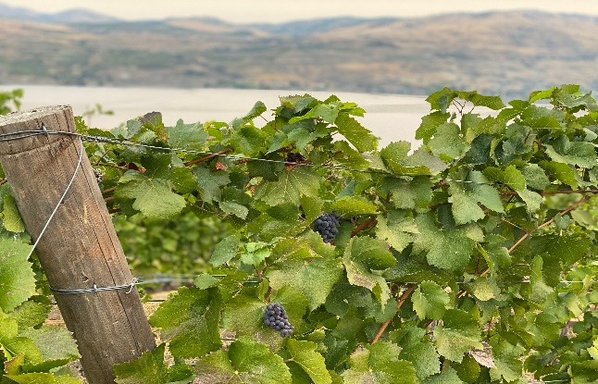
Above: Pinot Noir on vines, Chelan
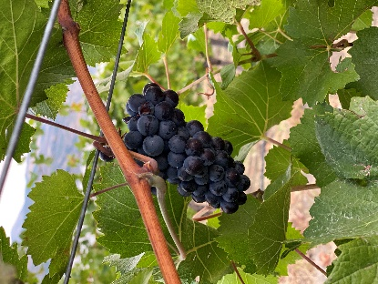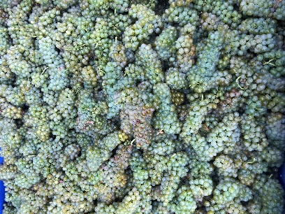

Left: Pinot Noir Cluster, Chelan Right: Chenin Blanc, Rattlesnake Hills

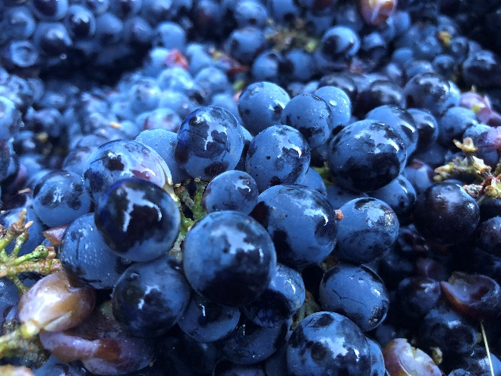
Above: Malbec for the 4xPlay Rose from Naches Heights

To our Lucky Bastard Club members, prepare yourselves for an amazing line up of our Fall Release wines. We will reveal the pick-up dates soon! If you have been considering becoming a member, now is the perfect time to launch! You won’t want to miss our limited production wines reserved for club members.

LUCKY BASTARD’s WINE CLUB 12 BOTTLES twice per year, FALL/SPRING 20% Discount on all purchases Choice of customization Access to limited production wines Annual private barrel tasting for you and 5 guests Annual Anniversary Invite Club pick-up event 12 Free Wine Tastings per year
*Membership eligibility after 1st case purchase, then commitment for Fall and Spring release case (12 Bottles) each release. Average cost per allocation is roughly $280.00 to $360.00 (excludes shipping). 30 day cancellation notice required.
You can sign up in our tasting room.

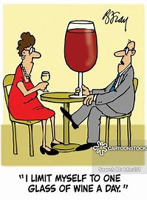

TASTING ROOM We still encourage booking tasting appointments to ensure all groups can social distance appropriately, you may do this through our website, www.uvafurem.com. If you haven’t been to our facility in the past few weeks, we have added a large outdoor event tent with a heater, fans and twinkle lights, so you can be comfortable even if the weather is not cooperating! If you are bringing in a group larger than 4, please email Maggie (Maggie@uvafurem.com) so that we may reserve a table large enough and also adjust the time allotment. You may also pre-order a charcuterie board from DaVine’s for your tasting appointment via email.
UPDATE: Under the current COVID-19 guidelines, we can seat parties of 6 guests. You are required to wear a face covering upon entering/leaving, and anytime you are not seated at your table. You are welcome to come into the tasting room to make purchases, please wear your mask and give other guests 6 feet of social distance. We are continually wiping down all surfaces inside and out for your safety.

CHEERS!
Thanks for reading and your support!
~The Uva Furem Crew

